**AUTOMATED SENSORIZED ELEVATOR**

JAIGANESH P

ECE STUDENT

SEC20EC078@SAIRAMTAP.EDU.IN

AKASH A

ECE STUDENT

SEC20EC166@SAIRAMTAP.EDU.IN

MAHIZHAN M

ECE STUDENT

SEC20EC023@SAIRAMTAP.EDU.IN

EXISTING SYSTEM:

In a normal elevator system when the button of the elevator system is triggered the elevator will moves to the desired floor where the button is triggered as per the command given by the CPU of the elevator. As per the command the elevator will move to the desired floor in a multi-floor apartment when the button is triggered even though the person is left from the elevator. This is the existing system of the elevator.

**ABSRACT: The project's primary goal is to minimise the wasted time and energy experienced when an elevator malfunctions. The field of embedded systems includes this project. This project uses a small amount of power, which saves energy. Goals 9 and 11 of the Sustainable Development Goals apply to this initiative. In modern life, we often choose elevators over stairs since they are more comfortable and take less time. In elevators, the main CPU system operates in accordance with the instructions given by the command box, which interprets the input from the elevator buttons. These buttons provide the primary input that the CPU uses to decide whether to move the elevator up or down. Additionally, it manages the elevator doors' opening.**

PROPOSED SYSTEM:

This project module is directly connected to the CPU of the elevator system as this module has a pressure sensor, it continuously reads the pressure change. This change in pressure assumes that there is a person is waiting for the lift then it also checks weather the button of the elevator is triggered if the both the conditions are true then the CPU will process the data and send the elevator to the desired floor. Either one of the conditions is false then the lift will not come to the desired floor. By this we can reduce the excess power consumption and also helps us to save time in our day-to-day life.

INTRODUCTION

The main objective of the project is to reduce the time and power waste while using the elevator. This project is mainly useful for multi floor apartments, companies and also for the hotels and soon., This project is coming under Sustainable Development Goals number 9 and 11. This project comes under the domain of embedded systems. In our day today life we mostly prefer elevators instead of stairs for our comfortability and to reduce the time waste. Sometime the elevator moves to the floors when the button is triggered but the person who triggered the button will left from the area but the elevator moves to the floor where the button is triggered and opens the door. This cause some power loss as the elevator functions even though there is no one in front of the elevator doors. we hope that our project can bring a solution to this problem.

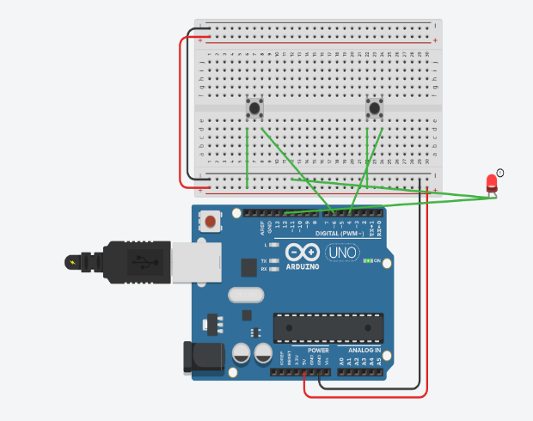

Future scope:

We have planned to improve this project by generating the electricity with the help of the pressure sensor used in this project as the mechanical energy from the pressure sensor is converted into electrical energy and that energy is used for emergency power functional unit which is used in the elevators during power failures.

Simulated image from thinker cad

Hardware requirements

* Arduino Uno
* Arduino Ide
* Bread board
* Jumper Wires (Male to Male & Male to Female)
* LED
* Push Button

References

Smart Elevator Cottrol System Based on Human Hand Gesture Recognition Shanghai Le, Quijano Lei*, Xinyang Wei, Jiahao Zhong, Yue Wang, Jimin Zhou, Weijun Wang Intelligent Robot & Equipment Center Guangzhou Institute of Advanced Technology, Chinese Academy of Sciences,2020 IEEE 6th International Conference on Computer and Communications.

Cai Z, Han J, Liu L, et al. RGB-D datasets using Microsoft Kinect or similar sensors: a survey[J]. Multimedia Tools and Applications, 2017, 76(3): 4313-4355.

Kabir R, Ahmed N, Roy N, et al. A Novel Dynamic Hand Gesture and Movement Trajectory Recognition model for Non-Touch HRI Interface[C]//2019 IEEE Eurasia Conference on IOT, Communication and Engineering (ECICE). IEEE, 2019: 505-508.

Liu shi-lei, The study concerning human-computer interaction used in the manual segmentation and identification of key techniques Shan Dong University,2017.

Laboratory Model of the Elevator Controlled by ARDUINO Platform Marijo Andrija Balug*, Tomislav Špoljarić* and Goran Vujisić** Faculty of Electrical Engineering and Computer Science, Maribor, Slovenia **University of Applied Sciences - Department of Electrical Engineering, Zagreb, Croatia, MIPRO, 2017

WORKING OF AUTOMATION SENSORISED ELEVATOR

From the following illustration, we'd like to create a circuit in which the sensor and button are connected to the Arduino and the led is the Arduino's output. Whenever the sensor recognizes humans as well as the button is pressed, the led illuminates. If one of these are missing, the led will not glow. This is how an automatic sensor elevator operates.

Conclusion

This goes to prove that this solution can fix the main issues with the elevator system while also saving time and energy by decreasing the elevators' needless movement between floors. Due to the direct connection between our project and the elevator system's CPU, it also helps us conserve electricity.